NAME : SHWETA
SRN : PES1UG24AM404

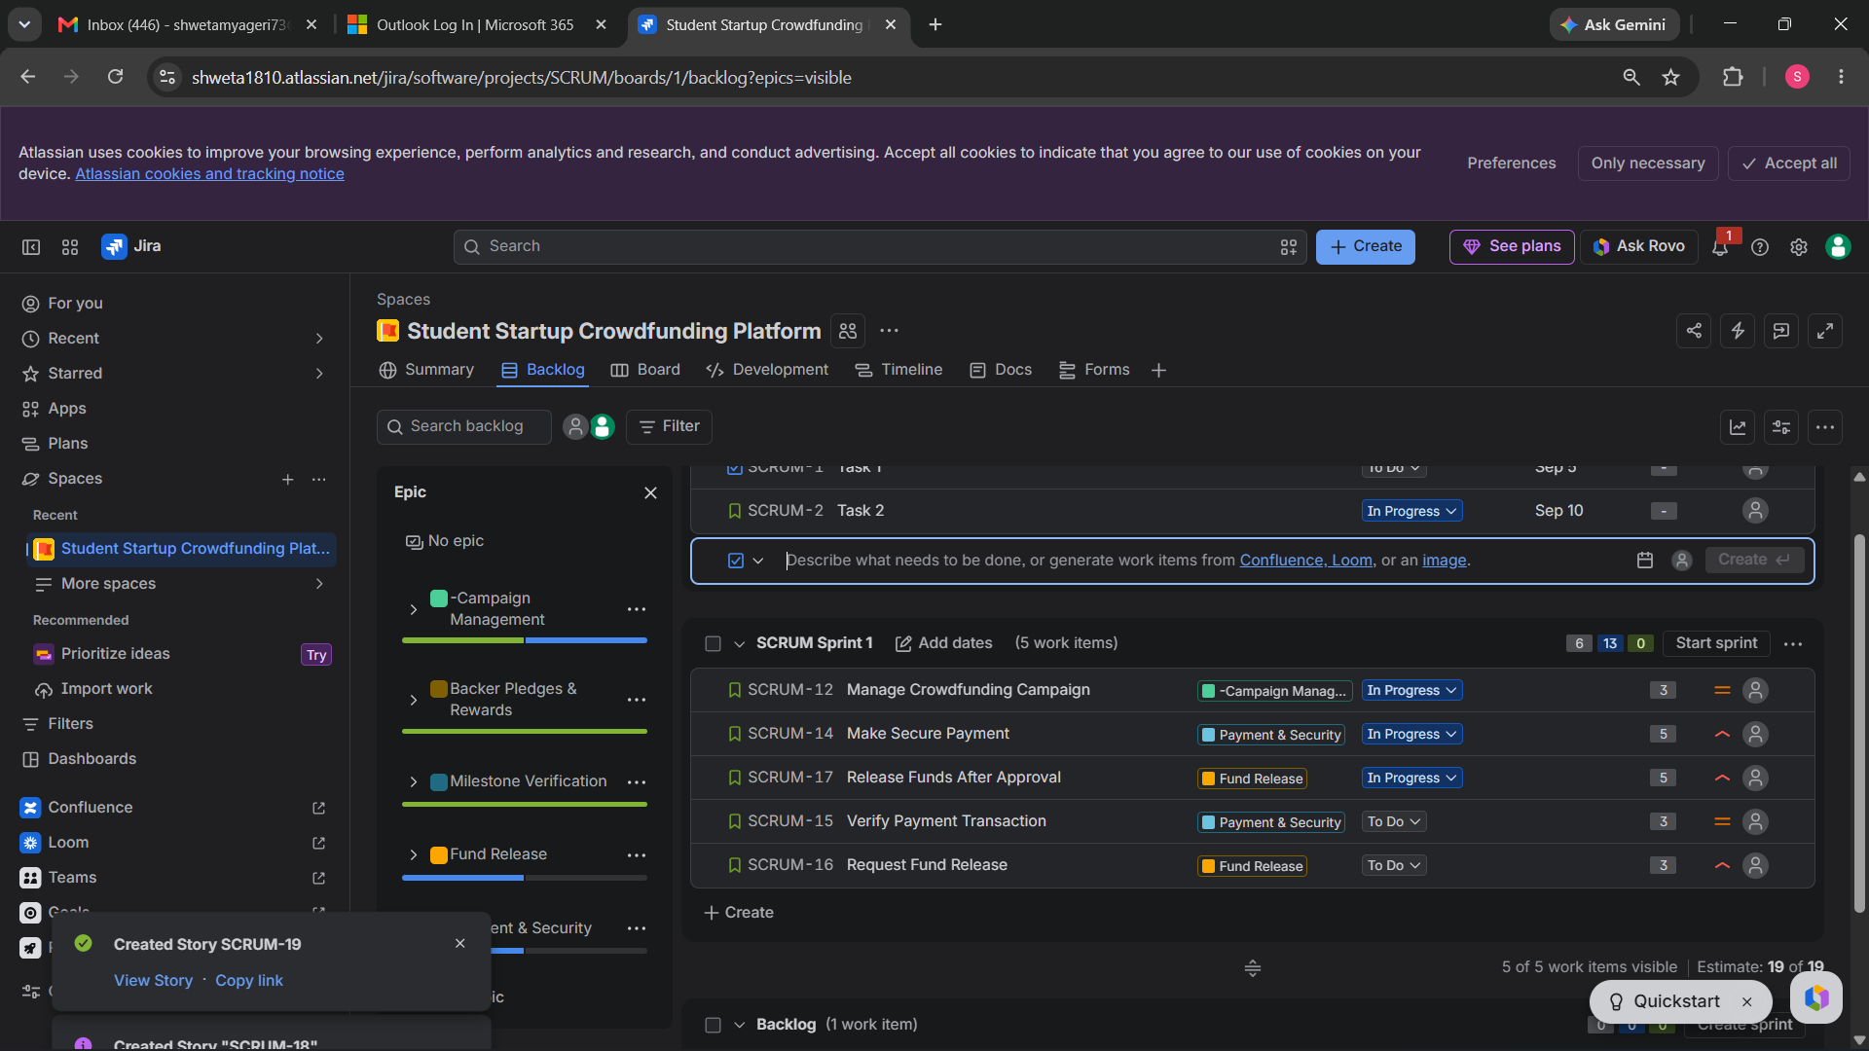

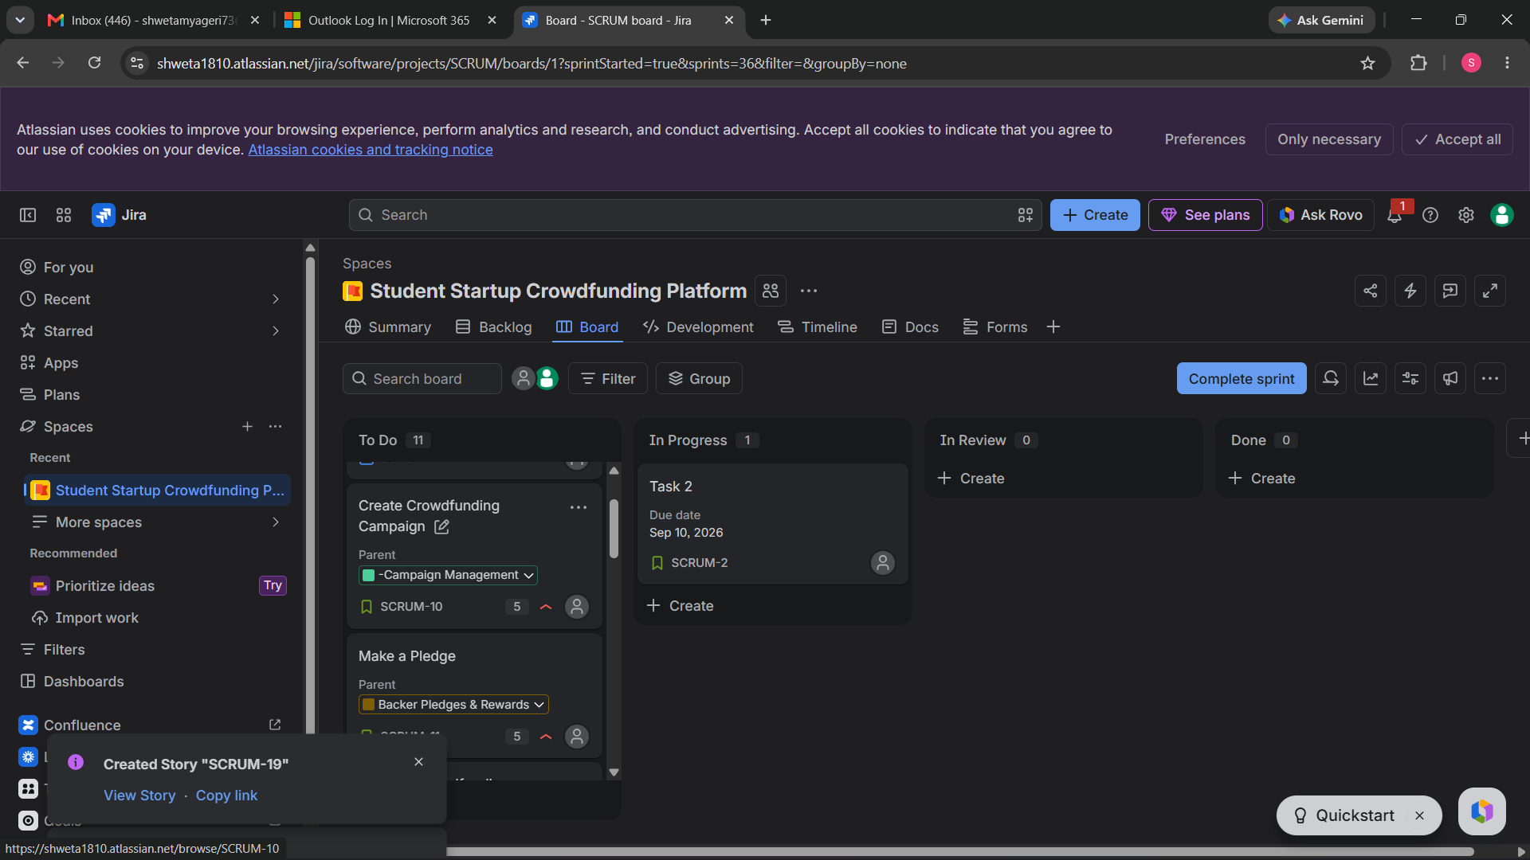
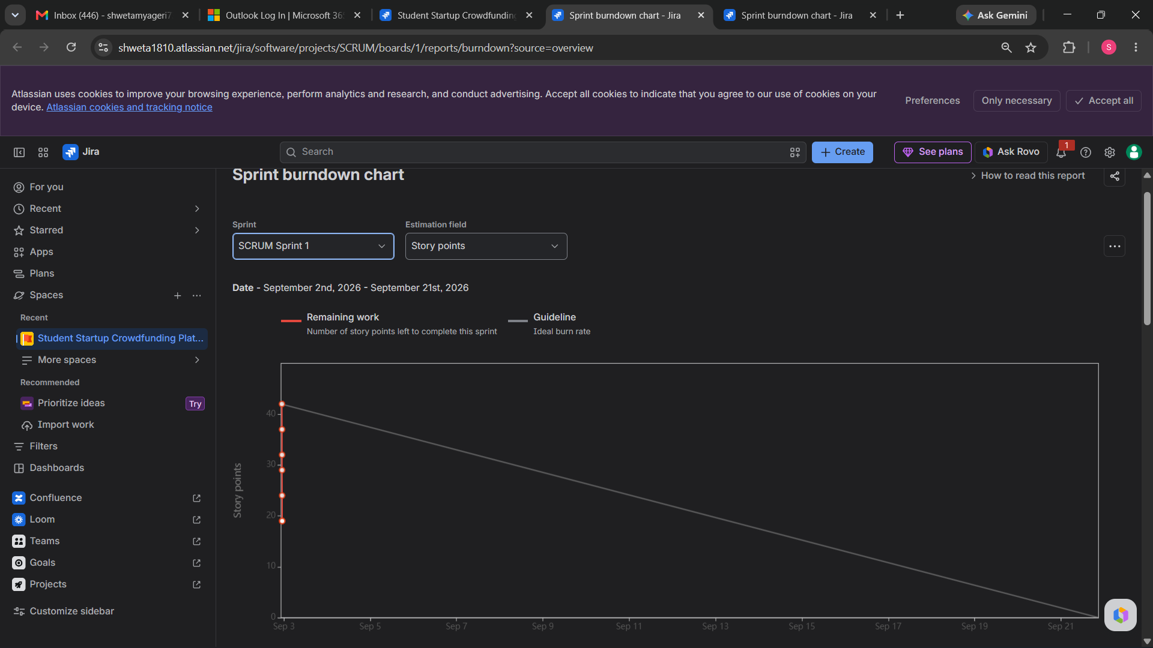
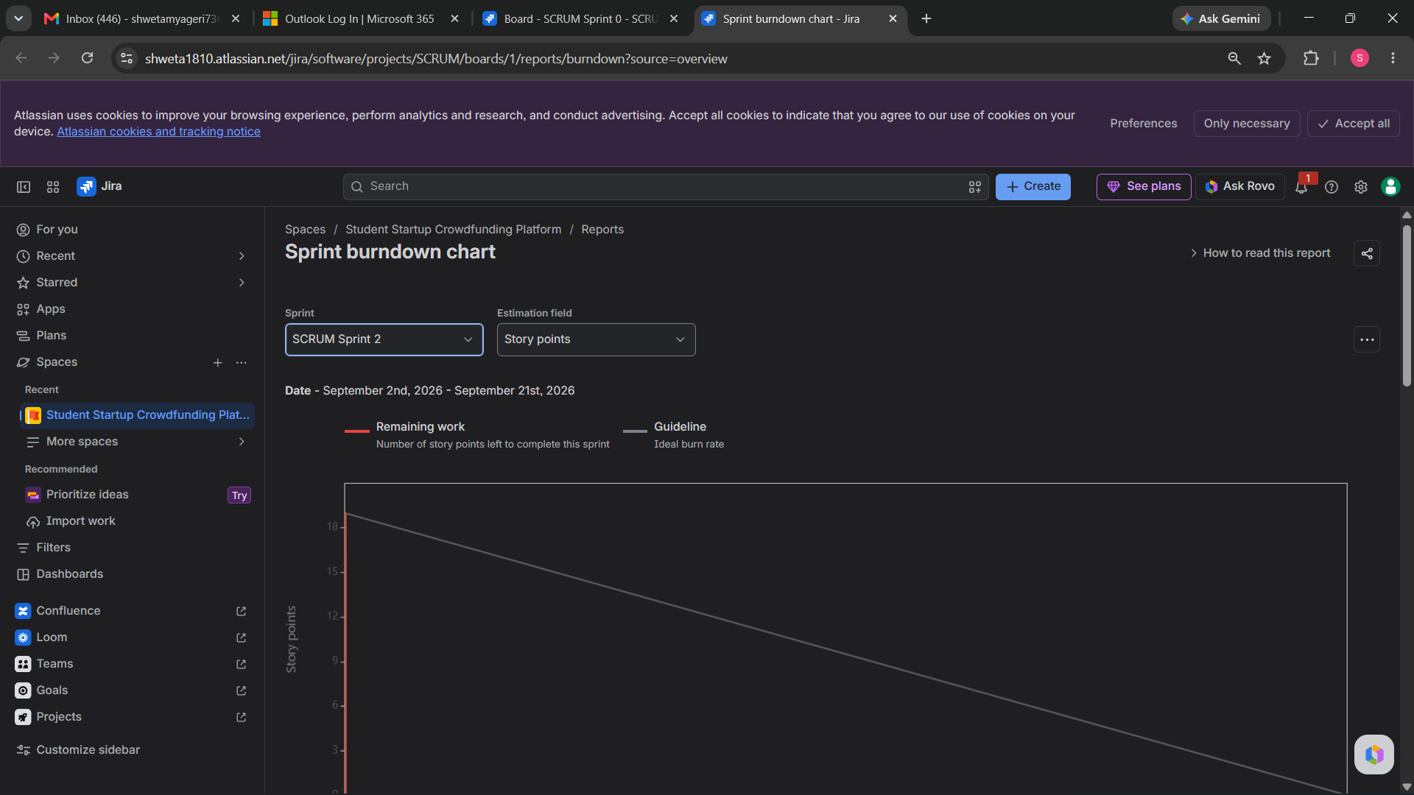

Lab 2 Reflection
1. What did you learn from this lab?
I learned how to convert project requirements into Epics and User Stories and organize them in Jira. I also learned how to prioritize stories, assign Story Points, create sprints, and track their progress using the Scrum board and Burndown Chart.
2. What challenges did you face?
The main challenge was understanding how Epics, User Stories, Story Points, and Sprints are connected in Jira. I also initially found the Jira interface confusing, but after using the Backlog and Board, it became easier to manage the work items.
3. How did Jira help in managing the project?
Jira helped organize the project into smaller tasks and made it easier to see which work was completed, in progress, or still pending. The Scrum board provided a clear view of the team's progress.
4. What did the Burndown Chart show?
The Burndown Chart showed the amount of remaining work during the sprint using Story Points. As stories were completed, the remaining work decreased.
5. How did Agile/Scrum help?
Agile/Scrum helped divide the project into smaller manageable pieces and allowed the work to be completed in short sprints. This made it easier to track progress and identify unfinished work.

